Creating and Switching to a New Git Branch:
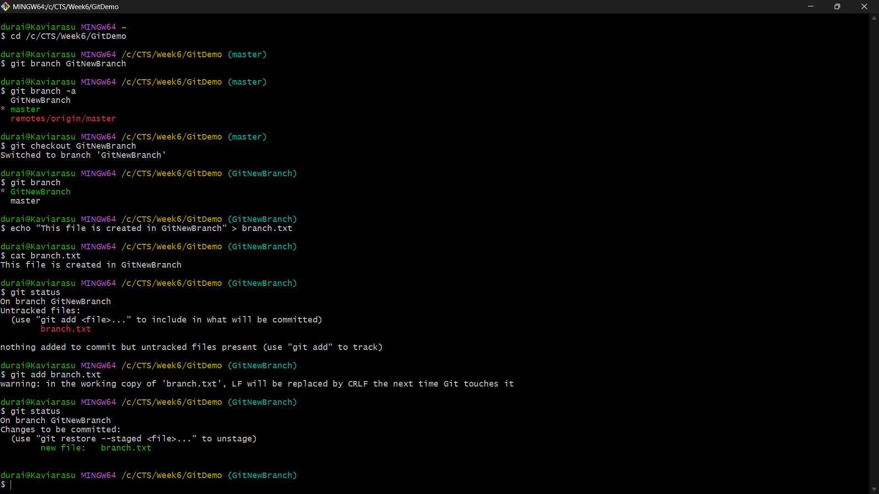
Creating, Staging, and Committing Changes in the Branch:
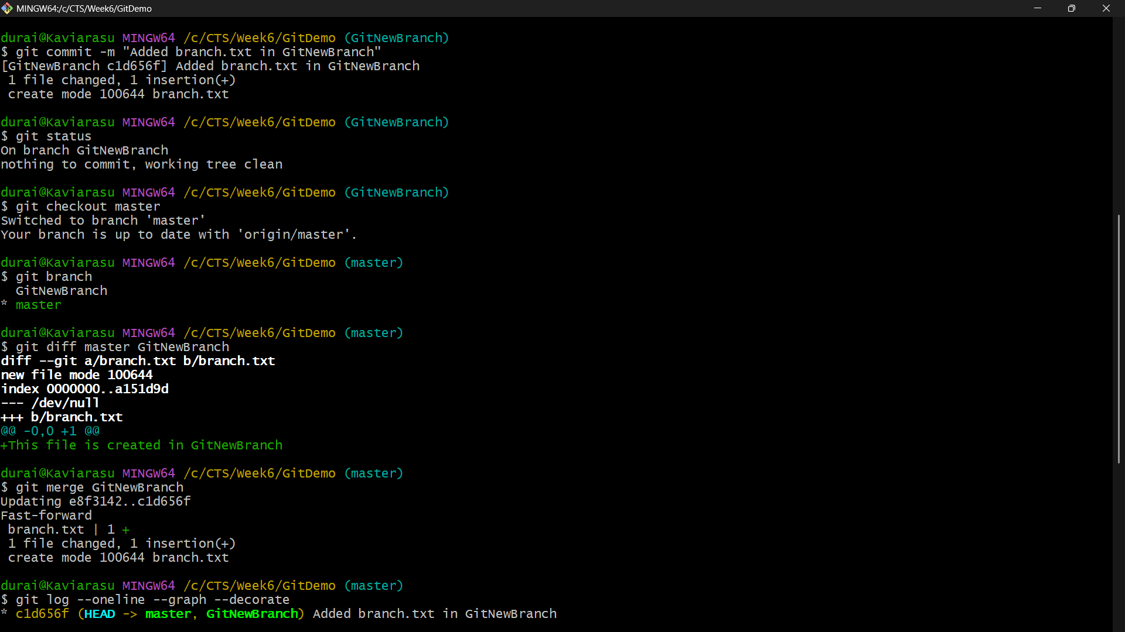

Merging the Branch into Master and Viewing Commit History:
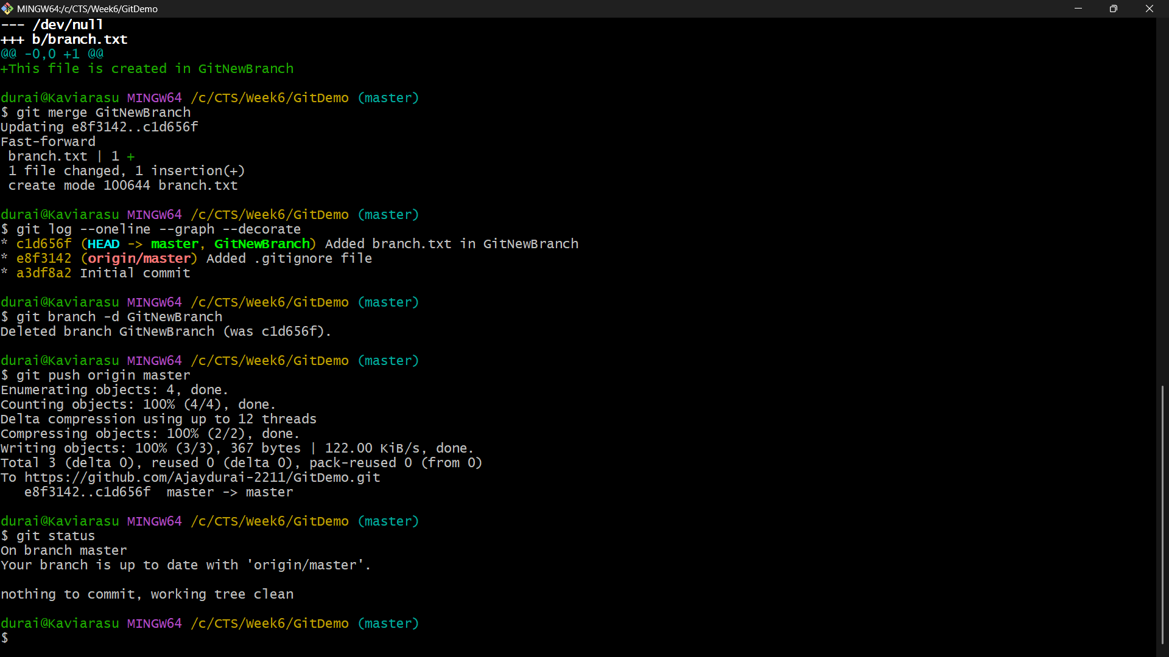
Pushing Changes to GitHub and Verifying the Repository:
